**Language Translation Mobile App**

Submitted By:

VERBANET TECHNOLOGIES L.L.C

**CONTENTS**

**1** **Key Details** 4

**2** **Goals & Aims** 6

**3** **Project Scope** 7

3.1 Proposed Solution Model 7

3.1.1 Stand- Alone Fixed Bid 7

3.1.2 Key Strengths of Our Solution 7

3.2 Users of the application 8

3.2.1 Admin 8

3.2.2 Application Users (Caller / Receiver) 8

4 Functional Requirements 8

4.1 User Registration 8

4.2 Communication Options 8

4.3 Message Encryption 9

4.4 Call Metering 9

4.5 Access to contacts 9

4.6 Sharing and Rating 9

4.7 App Permissions 9

4.8 Payment Processing 10

4.9 Google Ads 10

4.10 Application and User Preferences 10

4.11 General Information 10

4.12 Make New Voice Call 10

4.13 Create New Text Message 11

4.14 Admin Panel 11

4.15 How to Earn Free Minutes 12

4.16 How to Buy Credit 12

5 Application Architecture 13

5.1 Application Workflow 13

5.2 Message Sequence Sample 14

6 Non-Functional Requirement 17

6.1 Proposed System Environment 17

6.2 Technical Configurations 18

6.2.1 Development Tools 18

6.2.2 Recommended Web Hosting Package- Dedicated 18

6.2.3 Browser 18

6.2.4 Hardware Devices 19

6.2.5 Technical Standards 19

6.2.6 Technical Guidelines 19

6.3 Project Delivery 21

6.3.1 Project Management 21

6.3.2 Roles & Responsibilities 21

6.3.3 Delivery Activity Summary 21

6.3.4 Project Implementation Plan 22

6.3.5 Deliverables 23

6.3.6 Estimated Delivery Time 23

6.3.7 Deployment Details 24

6.3.8 Release Planning 24

6.3.9 Risk Contingency Planning 25

6.4 Project Assumptions 27

6.4.1 Objective 27

6.4.2 Design 27

6.4.3 Development 27

**7** **Out of Scope** 29

7.1 Change Management 30

7.2 Maintenance & Support 31

7.3 Service Level Agreement (SLA) 33

**8** **Terms & Conditions** 34

8.1 Acceptance Criteria 34

8.2 Warranty 34

8.3 Source Code & Intellectual Property Rights 35

8.4 General Terms and Conditions 35

8.5 General Administrative, Technical & Functional Assumptions 37

**9** **FINANCIALS.** 39

9.1 Hybrid Application Development 39

9.1.1 Payment Terms 39

9.2 Windows Dedicated Hosting – Optional 40

9.2.1 Payment Terms 40

9.2.2 Mode of Payment 40

**10** **About Us** 42

11 Glossary Of Terms 47

# **Key Details**

**PROJECT NAME CLIENT**

Real Time voice translation App Middle East Broadcasting Centre

**CLIENT CONTACT CLIENT ADDRESS**

Mr. James Smith P.O.Box 123

James.smith@mbc.com ABC Street

+971 4 234 534 Dubai

U.A.E

**PROPOSAL SUBMISSION PROPOSAL ID NO.**

05.02.19  AD/BP/05022019/1820/2

**PROPOSAL VALID UNTIL ANTICIPATED START DATE**

25.02.19 00.00.00

**PROPOSAL SUBMITTED BY PROPOSED TECHNOLOGY**

Simi Thomas ASP.NET / Android

Verbanet Technologies L.L.C

Dubai, U.A.E **APPLICATION TYPE**

+971 4 297 3236 Web & Mobile Application

+971 50 765 2345

simi.thomas@verbat.com

# **Goals & Aims**

Verbat shall develop a mobile application that will translate speech from one language to another in real time. Current voice translation services are limited to text translation services. Verbat shall develop a mobile app for the client that will translate speech in real time using bleeding edge technologies.

The mobile app shall have a friendly user interface that shall be intuitive, fast and accurate. It shall achieve this by using the following services viz.

* Transcribing services
* Translation services

Verbat shall develop API services that facilitate these.

# **Project Scope**

The client has approached Verbanet Technologies L.L.C., (hereafter referred under its trade / brand name as” Verbat”) to develop a mobile application that shall translate speech from one language to another. The user of the application shall select the language that they wish to speak in. His counterpart shall select the language in which they wish to speak. For example when the user has selected “English” and speaks in English, his counterpart may have selected “Arabic”. The counterpart w shall receive the message in Arabic and respond in Arabic. The user on the other hand shall receive the message in English. The application shall be developed in multiple phases. Phase one of the development shall focus on a minimum viable product.

## Proposed Solution Model

### Stand- Alone Fixed Bid

Verbat will be following a stand–alone fixed bid solution delivery model wherein the required solution would be devised and a suitable pricing would be offered. Verbat’s solution architects have conducted a thorough research on the requirements and have come to the conclusion that our proposed solution, which is detailed further in this document, will meet the requirements put forth by the client.

### Key Strengths of Our Solution

* Strong and Scalable platform accommodating to future enhancements
* A framework which acts as a solution accelerator with building blocks that can be re-used in n future for building new components and features.
* Our light weight framework used consumes fewer system resources thereby making the application perform faster.
* All security aspects are considered

## Users of the application

### Admin

Admin will set the languages that are available in the system for translation. Admin shall also be responsible for administering the system.

### Application Users (Caller / Receiver)

Users download the application from the mobile store of their choice. They shall use the application to communicate with other users.

# Functional Requirements

The mobile application shall have the following features

## User Registration

When the user downloads the application they shall be prompted to

* Enter their mobile number. (Optional)
* The user shall receive a confirmation code (Optional)
* If the user does not receive a confirmation code in 2 minutes they have the option to request for a new confirmation code
* Once the confirmation code is entered, the user is a registered user of the app
* The user then selects their preferred language for communication (Mandatory)
* The application shall detect the geographic location of the user (implies access to GPS)
* Users shall receive 10 minutes of translated calls and 20 translated text messages.

## Communication Options

The user shall have the following communication options

* Voice calls ( implies access to mic)
* Text messages
* Voice messages
* Share attachments (messages, images and video: implies access to image gallery and storage)

## Message Encryption

All messages exchanged between users shall be encrypted for security

## Call Metering

Users shall have free calls as well as paid calls. The admin shall restrict the amount of free calls (based on text length and time) users might have.

## Access to contacts

The application shall request access to the contacts in the user’s mobile directory. Once synchronized, it shall update the status of the users who have already downloaded the application. The app shall also indicate the country flag.

## Sharing and Rating

Users shall be able to share the app with friends and rate the app

## App Permissions

The App will request the following permissions from the user

* Microphone permission.
* Camera permission.
* Location permission.
* Sync contact permission.
* Push notifications.

## Payment Processing

The application shall support payment process using (TBD)

* Credit Cards
* Debit Cards
* Apple Pay
* Samsung Pay

## Google Ads

The app should support the display of Google Ad services. The admin shall be able to enable or disable these services.

## Application and User Preferences

The app shall allow the user to

* Set their preferences
* Edit their profile
* Change the preferences for the App

## General Information

The application shall contain generic information such as

* Privacy policy
* About Us
* Call log information

## Make New Voice Call

To make a new voice call, user shall

* Select the contact or search for the contact
* A pop up shall prompt the user to determine if it is a regular call or a translated call
* The application shall dial the contact after selection
* When connected a timer shall start with a clear indication of the time elapsed along with the call cost.
* If it is a non-translated call, the app shall make a call using a third party service.
* If it is translated call,
  + the app shall transcribe the voice into text
  + Convert the text from one language to another
  + Convert the text to speech and relay it to the receiver
* Since translation services requires the coordination of multiple activities, it may not function like a regular voice call, instead it may need to function like an intercom.
* Both the receiver and the sender may need to a press a button while they are conversing. When they are done talking, they shall release the button.
* All conversations shall be encrypted and logged for security

## Create New Text Message

Users may choose from their contacts to send text messages. User shall have the option to send plain text or have it translated to another language. User shall have the following options

* The message must display in both sender and receiver in 2 languages, which is the original and the “translated to”, the preferred language must be in big size and the other language in small size in the below.
* Message status indicator must display for the messages (Sent, delivered, read)
* Sender setting page must display which will allow for the user to make some actions like (Mute this sender, add to favorite ... etc.)
* The users must be able to send attachments (Images, Audio, video).
* Search field must be added to allow for the user to search in any text inside the message body.

## Admin Panel

After logging in admin shall have the following options

* Admin User management module.
* Push notification module: may be send by Gender, Country or all users. It may be send immediately or it could be scheduled
* Reports module: Reports should contain information on total downloads, Total number of brought credit, Total number of downloads by country
* Application users management module must contain a list of active users

## How to Earn Free Minutes

The following rules apply

* New registered users shall have 5 minutes of translated calls and 10 text messages
* Whenever the app is shared and downloaded, the user shall receive 2 minute calls and 4 text messages
* For every advertisement video watched, user shall receive 2 minute video calls and 2 text messages

## How to Buy Credit

The users must be able to buy credit by using the payment getaway in the app throw fixed packages as below:

|  |  |  |
| --- | --- | --- |
| Package | Calling minutes | Text messages |
| $1 | 20 | 40 |
| $2 | 45 | 90 |
| $5 | 150 | 300 |

# Application Architecture

## Application Workflow

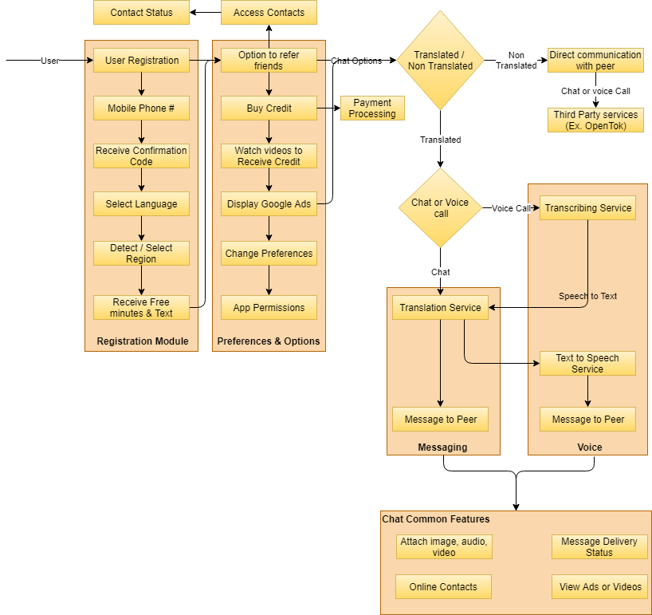

## Message Sequence Sample

Verbat shall use a real time messaging platform called Mesebo for direct peer to peer ausio calls or messaging that does not involve translation services. Mesibo is a proprietary platform that allows one to quickly develop applications with real-time messaging, voice and video calls.

We define real-time messaging with a few examples:

* You are sending ‘Hi’ to your friends over WhatsApp is a real-time message.
* You are sending a photo OR a location to your friends over Telegram is a real-time message.
* You are sending a request to Uber for a cab is a real-time message - it’s invisible to you but underneath what goes is a real-time message. Subsequently, Uber sending messages to group of drivers to get you a cab is a message (group message).

One of the distinguishing characteristic of real-time messaging is that messages are delivered as it happens, almost instantaneously. However, there are situations in which a real-time message may become non-real-time when one of the endpoints is offline. For example, you are sending a message to your friend in WhatsApp, here are possible outcomes:

* Your friend is online and she will get your message almost instantaneously, this is a real-time message.
* Your friend is offline. Server will store this message for you and it will be delivered to your friend when she is online again. This is how a real-time message (one you sent) can become a non-real-time message.

Mesibo is a high performance, high-availability, asynchronous real-time messaging platform that allows users (endpoints) to communicate with each other in real-time. Unlike other platforms, Mesibo is entirely written in C++ with state-of-the-art architecture and reliability to give you unlimited scalability from the day one.

Mesibo makes it extremely simple to enable real-time communication between your users. All you have to do is:

* Let mesibo know about every user in the system. Mesibo will create an access token for each user and pass it back using mesibo Server-side Admin API
* These tokens are then distributed to the users.
* Users use this access token to create a real-time connection with the server to send and receive real-time messages, voice and video calls.

A more elaborate real-life scenario below in which Alice and Bob registers with the backend server , each gets real-time access token from mesibo and starts communication in real-time.

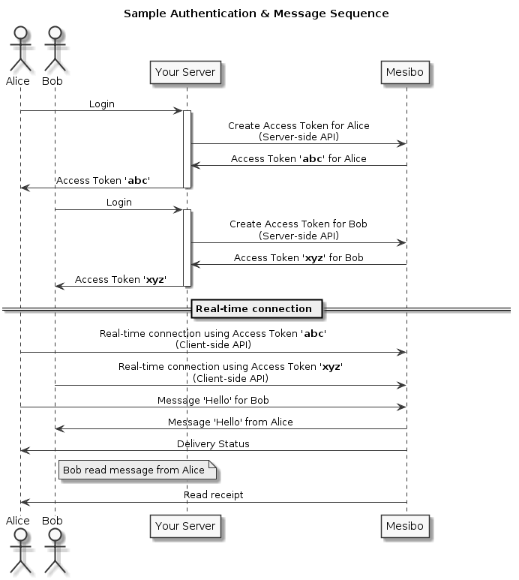

Chat Server

Chat Server

This API makes it extremely trivial to send and receive arbitrary real-time messages by using well thought-of design patterns. In short,

* To send a message, invoke one of the messaging APIs. Once you specify the destination (a user or a group), type of message, expiry if any, and your message. The API will send message and also inform about the status of messages sent in real-time.
* To receive messages, implement listeners (delegates in iOS). The API will inform the peer whenever you receive any messages or calls.
* Sending and receiving files can be implemented using the file transfer handler which will upload (to send) and download (on receive) files to or from your server (Between peers).

The service delivers messages instantly if the destination user is online. If not, messages will be delivered as soon as destination user comes online. This is automatic and transparent to applications, so applications sending messages do not need to worry if the receiving applications are up and running. Conversely, receiving applications do not need to worry about the status of sending application.

# Non-Functional Requirement

## Proposed System Environment

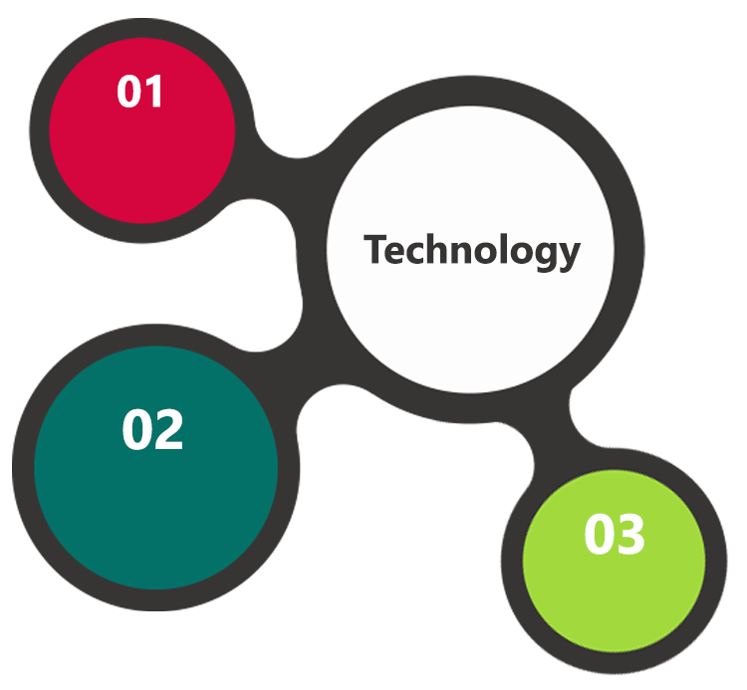

ASP.Net, MVC

, Android SDK

HTML5 / CSS3

Java Script

Windows

IIS

MS SQL

Android

**MS SQL2012  
Windows 8/10  
Web Services**

## Technical Configurations

### Development Tools

* C#, ASP.Net 4.5 / Android Studio / Java / AngularIO
* MS SQL
* HTML / CSS 3
* Photoshop
* Web services, Ajax, JavaScript

### Recommended Web Hosting Package- Dedicated

#### Hosting

* Operating System : Windows Server
* CPU : 2 core
* Domains: Unlimited
* Disk Space: 200 GB
* Monthly Bandwidth: 50 GB
* Web site Server Software – IIS 7.5 +
* ASP.NET 4.5

### Browser

The application developed shall be compatible with the browsers listed below:

1. Internet Explorer 11
2. Mozilla Firefox 50 or above
3. Chrome 50 or above

### Hardware Devices

#### Mobile device with the following specs

* The device should support LTE / Wi-Fi 802.11 a/b/g/n/ac
* The device should have 3 GB RAM and above memory

#### Web Server

We recommend the specification mentioned below for the best output.

* Microsoft Windows XP Professional SP3/Vista SP1/Windows 7 or 8 OS
* Processor: 2.6 GHZ Intel Pentium IV or equivalent
* Memory: 2GB
* Disk Space: 1 GB of free disk space

### Technical Standards

* Screen Resolutions

1080 x 1920, 720 x 1280, 750 x 1334, 640 x 1136

* Testing Devices

Google Pixel     Android 7

Motorola Moto G Turbo Edition -   Android 6

* OS Version

Android KitKat and above

### Technical Guidelines

The guidelines provide instructions and conditions that will be adhered to during the development of the mobile application.

* API will be used, as the case may be, in realizing the features and functionalities mentioned
* The client will finalize the functional requirements and UI/UX before the commencement of the project
* Verbat will be testing the app in the mentioned devices only. Testing on devices other than the ones mentioned under the “Technical Standards “ will have to be specified and provided by the client at the beginning of the development phase
* The client will have to provide the details of the testing devices they are using before the start of development phase
* Client **should** provide the relevant Developer's Account credentials before the development phase. In case Verbat needs to create the developer id additional charges will be incurred by the client
* The duration mentioned in the project time line is for development and testing and any delay or time taken by the review team to respond will not be Verbat’s responsibility
* Any clarification required from client needs to be addressed within 24 hrs.
* The apps will be developed / created within the guidelines of Android play store.
* Verbat will strictly follow the guidelines provided by the respective stores.
* Verbat will inform the client if any of the client requirements / request deviates from it.
* Customization of the features of the app will be susceptible to the limitation imposed by the respective platform/ store.
* Once development commences the test device/screen sizes will not be susceptible to change. Any change requested by the client will have to go through change management
* OS version support will be limited to the ones mentioned in the technical specifications. Further support will have to go through change management

## Project Delivery

### Project Management

The Verbat development center strictly follows industry standards on quality. The project management is process governed by the Verbat Quality Management system and is put to verification through internal audit programs that happen from time to time. Verbat will dedicate a project manager for the proposed implementation. Verbat proposes Client to identify one project manager who will be driving activities to be undertaken by Client to be the single point of contact for Verbat.

### Roles & Responsibilities

Verbat will assign a dedicated Project Manager/Project Lead to lead the project, who will be the first point contact for Client. He/she will be responsible for planning and managing the various activities within the project. He/she will work closely with Client Project Manager, to give periodic status updates and ensure high level of visibility and comfort on the progress of the project. The Project Manager/Project Lead will lead the co-ordination between Verbat and Client, thus enabling smooth transitioning of Client requirements to the Verbat ’ offshore delivery team, and provide visibility as well as comfort on the progress of the services to Client.

He/she will have periodic meetings with Verbat ’ Senior Management, thus ensuring Verbat ’ Management commitment and focus on Client initiatives.

### Delivery Activity Summary

|  |  |
| --- | --- |
| Activities | Description |
| Detailed requirement Analysis | Verbat team to conduct detailed study of requirement for the phase. If clarification is required, team will reach out to Client for more information and/or time for discussions. |
| DB Design | DB design for central and test DB. |
| Software Requirement Specification document (SRS) | Once the requirement analysis is completed, Verbat team will submit the SRS document for approval |
| UI/UX Design, Prototyping | Based on the SRS, Verbat UX/UI team will work on the UI/UX of the screens and submit for approval |
| Functional Specification Document (FS) | Once the UI/UX is approved, Verbat shall submit an FS document for approval. |
| Development | Actual system development starts based on the FS. This involves detailed design and software development of Web Application. |
| Testing | Test Planning, test plan creations, internal, integration testing and user acceptance testing. |
| Deployment | Deploying the latest built in the Verbat Test Server. |

### Project Implementation Plan

Verbat will be providing the solution in a stand-alone fixed bid approach which ensures minimum viable solution for quick wins with core focus on the long-term business objective and outcome. Once the implementation is over, Verbat will initiate the application maintenance process (once the maintenance contract is signed) which continues to extend after the implementation.

### Deliverables

### Estimated Delivery Time

The effort estimated for delivering the application will be as below:

* Twenty (10) UAE working days for the UI/UX from the date of approval of the SRS
* Fifty (50) UAE working days for the development of the application from the Date of Approval of the FS.

| **Activity** |
| --- |
| Contract Signoff (T0) |
| Project Initiation & Initiating requirement gathering |
| Software Requirement Specification Document(SRS) |
| SRS Approval (T1) |
| System UI/UX-Complete |
| System UI/UX-Approval (T2) |
| Functional Specification (FS) |
| FS Approval (T3) |
| Development Phase-Complete |
| Perform QC (Unit Testing and Integration Testing) |
| System ready for UAT |
| UAT Acceptance on Verbat server (T4) |

* The above-mentioned timeline is in UAE Working Days
* The initiation of the UI/UX development is dependent on the confirmation of SRS. SRS will be submitted post the confirmation of the project along with LPO, signed proposal and advance payment
* The above mentioned timeline for development is post the confirmation of FS
* Documentation submitted after project initiation and system study supersedes any proposal or documentation submitted during initial requirement gathering / discussion / negotiation
* Project plan will be submitted post the confirmation of project with necessary payments
* Any delay in getting the approvals of deliverables from client will cause change in timelines and the revised timelines will be updated in weekly status reports shared with client after the project commencement
* All approvals and queries regarding the client requirement and any queries which may hinder the project advancement at any stage should be answered by the client within 24 hours from the time of initiation, failing which the time delay will get added to the actual effort and timeline which was estimated.
* On project confirmation, Verbat requires a lead time of minimum seven (07) days for resource mobilization.

### Deployment Details

* Client can opt for hosting the application at Verbat’ Server.
* If deployment is at the client’s server, responsibility of deploying the application onto the production environment after conducting the necessary acceptance testing will lie with the client unless and until Verbat ’ support is contracted for deployment.

### Release Planning

* Client will be informed about the release date and time through email.
* Client performs the UAT

### Risk Contingency Planning

Verbat has identified various risk factors associated with this assignment and understands the impact of these risk factors on the project schedules. The objective of this section is to highlight for both Verbat and client, the risk factors, to analyze the impact of the risks on project execution, and to propose strategies to control and reduce the impact of the risk factor. These various risks, which could arise during the project, are tabulated below along with mitigation implementation.

| Type of risk | Impact | Risk Mitigation | Risk Handling |
| --- | --- | --- | --- |
| Scope Creep | H | Functions and features will be detailed in system requirement documents and will go through client approval. Once this document is approved, any change to requirement will go through change management review for possible impact assessment. | Proper change management procedure will be implemented. |
| Delay in customer feedback | H | The plan is prepared with enough lead-time for customer reviews and approvals.  The customer is indicated with the dates when the document is expected after review and approval. | The request for feedback will be escalated if not attended at the right time so that the schedules are not affected. Deemed acceptance criterion is set up front and will be followed. |
| Non-availability of necessary software’s, frameworks, database instances and infrastructure at client’s hosting environment(If hosting support is provided by Verbat ) | M | Client will be informed in advance on these requirements. | Possible impact to schedule. |
| Manpower attrition | L | All efforts would be made to ensure process dependence rather than being person dependent. As a risk mitigation plan Verbat will train backups. | A new person will be identified as early as possible, provided the required project-specific training and mentored by the senior members of the team to minimise impact of attrition on the project. |

*H-High, M-Medium, L-Low, NA-Not Applicable*

## Project Assumptions

The project solution and technology is created from the initial understanding of the requirement shared with Verbat through mails and meetings. The proposed solution is based on the following assumptions:

### Objective

* The requirement is to develop a smart security patrol system (web & android) with the functionalities as defined in ‘Functional Requirements’ section

### Design

* Client to provide Verbat with the branding guidelines.
* Color theme shall be provided by the client
* Client shall provide licensed images and logos in specified size & format
* Client shall provide the text and associated images for the proposed application. Text should be provided in digital format preferably in MS Word 2013 or above
* Verbat may use template based design for the application
* The application designed for mobiles will be in portrait mode

### Development

1

Client shall procure the following services

* Mesibo Services

Mesibo Pay you Go Service details are listed below

|  |  |
| --- | --- |
| **ITEM** | **Pricing per Month\*** |
| Monthly Active Users (MAU) | USD 0.001 per MAU |
| Concurrent Users** |  |
| Bandwidth | USD 0.9 / GB |
| Storage | USD 2.5 per GB |
| Monthly Commitment | USD 49 |

**\*** Pay as you go rates will be applied only when you cross the free tier limit during each billing period, subject to the monthly commitment of US$ 49.

**\*\*** Concurrent users limit will be 10% of the MAU. However, in case you cross 10% limit, it will be compensated by billing you for MAU = (concurrent users X 10).

* Google Transcribing Services ($0.006 USD / 15 seconds*)
* Google Translation Services ($20 per 1,000,000 characters*)
* Application shall be developed as a hybrid application so that it can be deployed on both IOS and Android
* Additional charges may be incurred for archiving and encryption services. (depends on the requirements)
* Peers making use of translation services are likely to experience a latency which is directly proportional to the bandwidth of their network connection.
* Peers making use of translation services may have to converse through an intercom like interface
* The application requires a fast internet connection for real time communication

# **Out of Scope**

With the ever evolving digital market, the requirement should be clear to both the parties involved, hence the importance of mentioning the out of scope details of the project. Following are considered to be out of scope while creating this proposal:

* Purchase of images, fonts
* Any language other than English
* Migration of existing data / Database migration
* Content writing / proof reading / Data Replication / Manual data entry
* Content or image procurement or uploading or editing
* iOS App Development / Android App development
* Developer account creation and Maintenance (IOS and Android Store)
* Adding new features to the application other than mentioned in the functional specifications. Such requests will be handled via change management. *For Change management details, please refer section titled “Change Management” in the Proposal*. (refer to section 4.1)
* Annual Maintenance Contract (Bug fixing, debugging, enhancements) – Please refer section titled “Maintenance and Support”, unless contracted for.(refer to section 4.2)
* Hosting Infrastructure and Maintenance (web and email hosting), unless contracted for.
* Application Deployment on the server and respective stores, unless contracted for.
* Backup solution and Disaster recovery unless contracted for.
* Physical deployment onsite / installation of the application in devices and Physical connection, installation of system.
* Integration with third-party, if any, other than mentioned in the functional specifications
* Hardware Integrations / procurement and purchase
* Procurement of SMS gateway / payment gateway / email gateway
* Integration of SMS gateway / payment gateway
* SSL Purchase and installation, if any
* Plugin/template purchases, if any
* OS other than mentioned in the Hardware Interface
* Relevant / related software libraries
* Mobile offline access or operations

## Change Management

Any addition which comes out of the project scope, upon and after the launch of the application will be considered as change management. Verbat recommends the following change management procedure for the same.

* Any change which comes out of the project scope, which was discussed, documented, and mutually approved by both the parties in the requirement stage, will be carried out only through raising a change request.
* Change request will be studied and an impact analysis on the existing work flow will be performed.
* On finalizing the impact, effort estimation for the change will be calculated and raised as additional requirement.
* Verbat will initiate the change request only after getting a formal approval from the client for the additional changes raised.
* Any change from the scope will be charged at AED 1,200.00 per man day effort and approval from the clients will be availed before commencing on any change management.

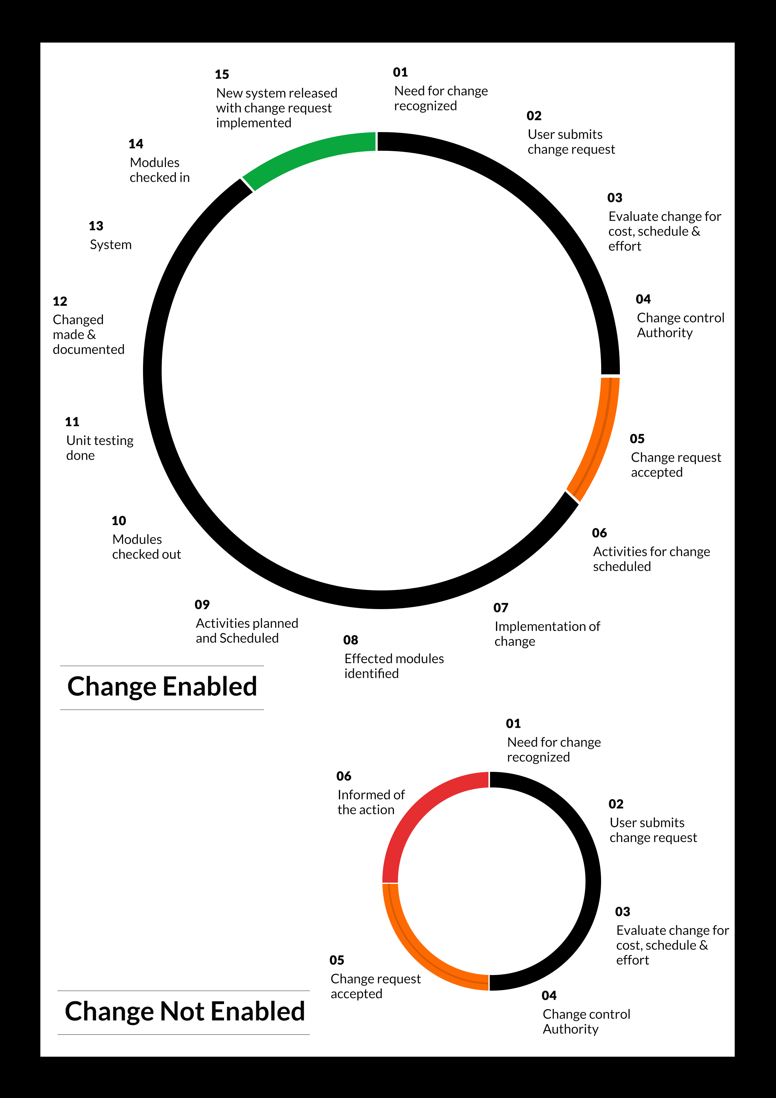

## Maintenance & Support

* Maintenance contracts by default are supported as per the basic SLA terms.
* AMC with Basic SLA is charged at 25 % of the total project value. Additional Effort/change management request will be added towards Total Value of the Project to determine the AMC value.
* Maintenance support is limited to providing application support for ensuring the consistency of the look-and-feel, bug fixes and user issues i.e. maintenance and support of the existing features of the application.
* Support does not in any way cover providing technical or other support to the end users. The maintenance agreement does not include functionality changes or feature additions which are handled as change requests which will be charged AED 1,200.00 per man day. AMC does not include server support, maintenance and application deployment.
* AMC charges will cover Off-Site Support and Debugging. Support includes E-mail, Telephone and Chat unless explicitly specified. In the event, the application is hosted with the client; necessary remote desktop connectivity **should be** provided for carrying out maintenance activity.
* Gap in AMC - In case if the client does not opt an AMC for a year and want to renew it after that period, 50% of the AMC amount for the year for which AMC is not taken will also be payable if the client wishes to renew the AMC contract.

*Note:*

* *Please note that the AMC support shall start only after all the necessary sign-offs (AMC Document) to this effect have been given.*
* *It is not mandatory that the client* should*opt for an AMC (replace with perhaps : It is mandatory that the client opts for an AMC) . The client will still be supported on an ad-hoc basis on an agreed man-day rate.*
* *AMC Payment Terms: 100% to be paid as advance.*

## Service Level Agreement (SLA)

|  |  |  |  |  |
| --- | --- | --- | --- | --- |
| **SLA Type** | **Max Response Time** | | **Max Resolution Time** | **Target** |
| Basic | 1  working day | 3 working days | | Request / incident / problem tickets |
| Advanced | 5 Business Hours | 12 Business Hours | | Request / incident / problem tickets |
| Priority | 3 Business Hours | 5 Business Hours | | Request / incident / problem tickets |

*Note:*

* *We provide Basic SLA as standard with AMC while Advanced and Priority SLAs attract additional charges.*
* *Time zone applicable (8:00 am to 5.00 pm, Sunday to Thursday)*

AMC Option:

Client can opt for time and material based Annual Maintenance, the details of which will be shared post the completion of project.

# **Terms & Conditions**

## Acceptance Criteria

* UAT (User Acceptance Test) sign off **should** happen within 07 Days from the first release of the application and the acceptance confirmation needs to be mailed to Verbat failing which Verbat will consider the project as approved by the client.
* Any comments or reason for rejection need to be documented and the same needs

to be sent as an email from the official mail id of client to Verbat on or before 07 days

from the first release.

* Timeframe for acceptance for any further release will be mutually agreed and finalized between client and Verbat depending on the UAT Comments

## Warranty

* Verbat shall provide a bug ﬁx warranty at no additional cost for 30 days from the date of acceptance of the project, for correction of any errors in the developed application that may be attributed to Verbat.
* However, this does not cover modifications by Client, or use of the application on an environment other than the proposed environment, or other circumstances outside Verbat’s reasonable control. In such a case Verbat reserves the right to charge for its services.
* All error corrections will be executed at Verbat India office. In the event of any need for on-site work, all expenses incurred for such trips will be payable to Verbat by Client.

## Source Code & Intellectual Property Rights

* Upon completion of the Project and 100% completion of the payment, client will have access to the source code except for propriety codes, developer tools and third party applications **etc.**
* The solution offered will be the intellectual property of the client and will be made available to the client on an “unlimited license” basis.
* Modifications by third party/person: No person or organization, other than Verbat or any person authorized by Verbat in writing, has any permission to modify/change the software Solution to be eligible to get continued support from Verbat as per the support terms defined under this document.
* Liabilities/Damages: Verbat accepts no liability or damages of any kind arising out of use or non-use of the software delivered. The responsibility of testing of software lies with Client.

## General Terms and Conditions

* Offer Valid for 30 calendar days from the date of submission of the Proposal.
* An average of 20 working days are assumed in a month.
* All the projects activities will be carried out from our off-shore development center in India
* All the documentation will be provided in English.
* Third party components may be used to develop this application.
* The scope of the project is to develop the Application as detailed in the scope of the project and mentioned in this proposal. Any changes or additions will have to go through change management.
* This proposal **would** have been derived or concluded from either the RFQ /RFP/data shared via email / information transferred during an initial requirement analysis meeting / tele-conversation. Verbat reserves the right to change the terms of this proposal as the final terms (including the costing), features & functionalities and timeline could change during the course of the project. Hence any fees quoted / timeline committed in this proposal may not be considered as final unless agreed and signed by both parties.
* Web Application will be best viewed only in the environment mentioned in the section Browser Compatibility
* Mobile app will be best viewed only in the environment mentioned in the section Hardware Interface
* All Source Codes and other project artefacts **would** adhere to the Verbat document templates and internal coding standards.
* The documents delivered to the client includes the ones mentioned under ‘Deliverables’ and these will adhere to Verbat’s internal document standards.
* Acceptance criteria shall be based on the clauses which were mutually discussed between Verbat and client at the Requirement Analysis phase and the same will be documented and approved by both parties through official emails
* In case Client requires any extension of the proposed acceptance schedule, the associated effort and cost of such extension can be mutually reviewed.
* For any circumstances if project needs to be put on Hold / Stop it requires minimum request notice period of 1 week along with duration for which request will be addressed by management and final decision on the request will be based on that
* If deployment is done in client’s server, Verbat cannot be held responsible for any performance issues arising due to hardware malfunctions.
* Client is responsible for data backup in case the application is not hosted on Verbat server.
* Source code will only be delivered or uploaded on the Production Server once the due payments are made.

## General Administrative, Technical & Functional Assumptions

* Detailed system study is required before the start of the project.
* During the requirement gathering phase, authorized personnel from the Client’s side is expected to be available for discussion and finalizing the HLD (High Level Design), before development commences.
* Type of reports and formats, if under the scope of the project, needs to be specified by Client before project sign off.
* Workflows if under the scope of the project, need to be specified/ confirmed by client before project signoff.
* Verbat assumes that all sign-offs from Client will be provided within agreed and specified timeframe.
* Client will provide all the necessary contents, both text and image, before starting the project in the format suggested by Verbat (if any).
* The client **should** provide the relevant information and data well in time for the execution of a related activity. Non- availability of this information or data may lead to an interruption of work which may result in a delay in delivery as well as additional costs to the client.
* Client **should** have/possess server with technical specifications as suggested by Verbat for the proposed application.
* Client will be provided with one time training (train the trainer) on how to use the application via video conference (maximum of 4 hours). Additional training requests will be charged.

# **FINANCIALS.**

## Hybrid Application Development

|  |  |  |
| --- | --- | --- |
| **No** | **Description** | **Amount (AED)** |
| 01. | Development of:   * Web Application for Super admin, Site Admin, Resolver and Viewer * Android Mobile Application for Patrol users * Active Directory Integration for user authentication |  |
|  | **Total Project Cost** |  |

*Note:*

* *The above cost is exclusive of VAT applicable in UAE*
* *The above cost is based on the initial understanding of the requirement grounded on the details shared by client. Any further changes in the scope or complexity if encountered during detailed system study/ analysis will call in for additional effort and time.*
* *The above cost does not include Application hosting, integration with any other third-party systems, deployment unless explicitly mentioned in this proposal.*
* *For feature additions, please refer section titled “Change Management “.*
* *LPO to be raised in the name of “Verbanet Technologies LLC” for project initiation*
* *Refer section 7.3 for ‘Mode of Payment’.*

### Payment Terms

* 30% () of total project value to be paid as advance along with the Purchase Order
* 40% () of total project value to be paid on confirmation of the UI/UX
* 30% () of the total project value to be paid on completion of Development and UAT on Verbat test server

*Note:*

*Payment should be made within 7 days from the date of invoice.*

## Windows Dedicated Hosting – Optional

ITEM NO. DECSRIPTION AMOUNT (AED)

1. Windows Dedicated Hosting

TOTAL PROJECT COST

*Note:*

* *The above cost is exclusive of VAT applicable in UAE*
* *Refer “Windows Dedicated Hosting Proposal” for detailed Server specifications.*
* *Refer section 7.3 for ‘Mode of Payment’.*
* *LPO to be raised in the name of “Verbanet Technologies LLC” for project initiation*

### Payment Terms

* 100% advance payment along with Purchase Order to initiate Server purchase

*Note:*

*Payment* ***should*** *be made within 7 days from the date of invoice.*

### Mode of Payment

By Cheque to Verbanet Technologies LLC

OR

Wire transfer to our bank account

Bank Name : Emirates NBD

Account Name : Verbanet Technologies LLC

Account Number : 1011492858201

IBAN Number : AE61 0260 0010 1149 2858 201

Swift Code : EBILAEAD

Bank Address : Mamzar Branch, Dubai

*Note:*

* *Bank charges incurred during wire transfer to be borne by the client.*
* *Any local taxes / VAT applicable to be borne by the client*
* *Client invoices will include VAT charges in addition to the application cost*

# **About Us**

Education

Transportation



Please add our latest brochure pages here – except page 2

Shibu – your support is needed here please

A quick and rough cut and paste already attached

Please format neatly – so it sits in the body of the page

Ensuring all the latest pages only..

Charts which are colour heavy like the one below need to be reversed and put into a colour scheme where black and orange is minimized

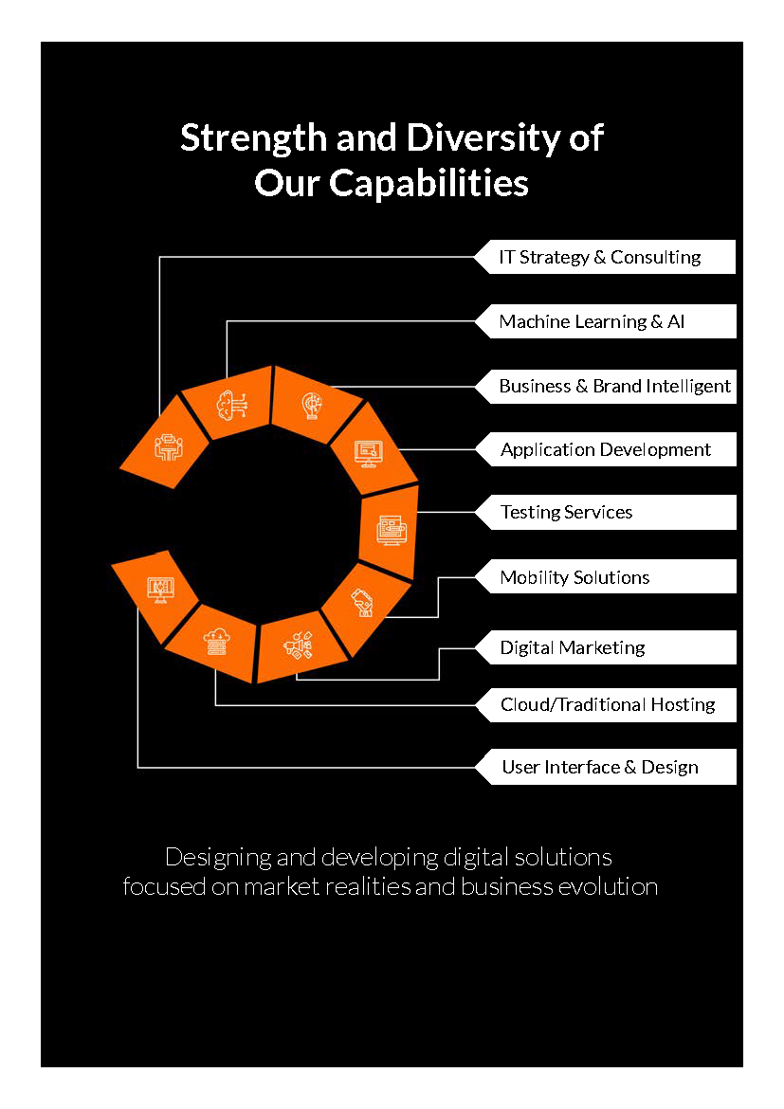

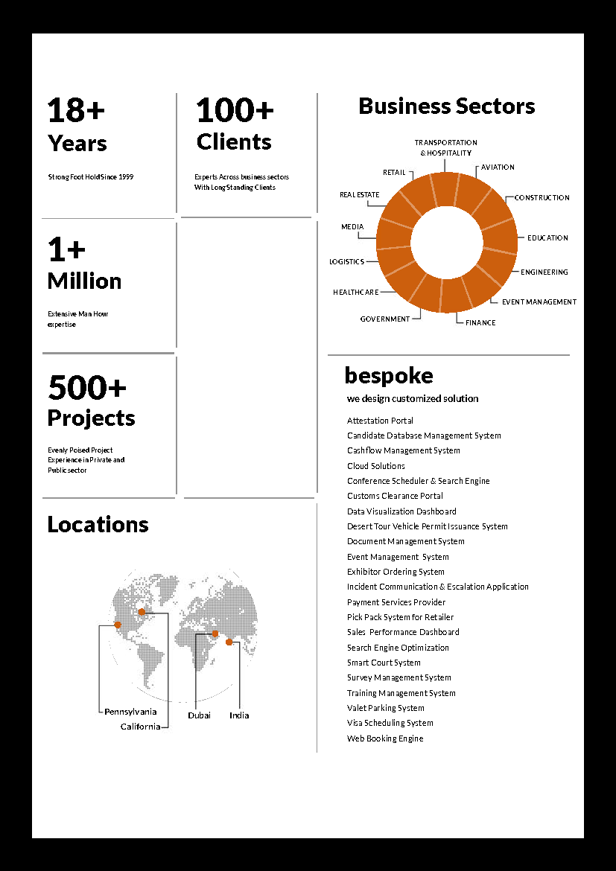

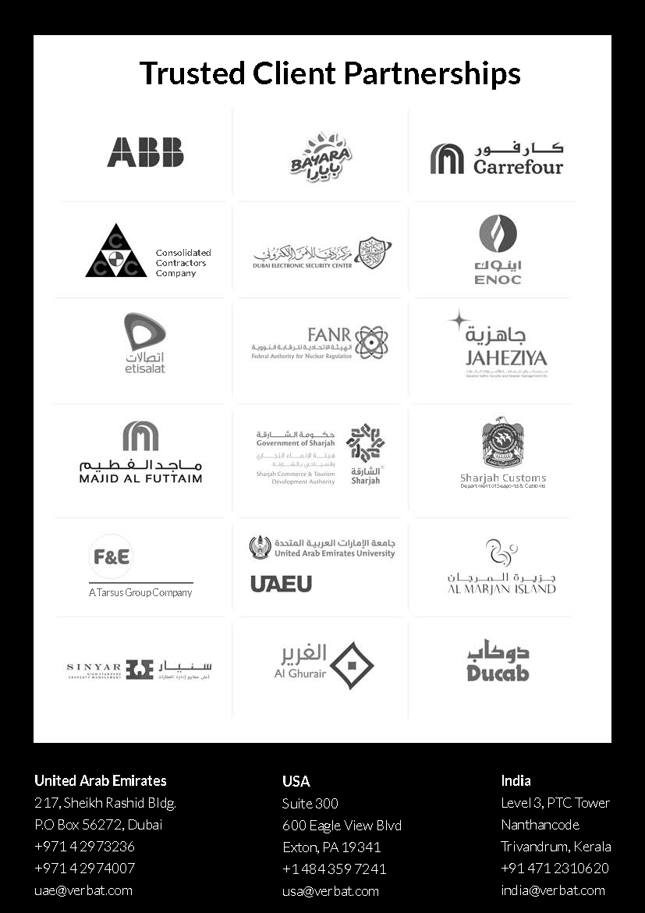

**Conﬁdentiality Notice:**

**This Proposal is conﬁdential and contains proprietary information and intellectual property of Verbanet Technologies LLC. Neither this proposal nor any of the information contained herein may be reproduced or disclosed under any circumstances without the express written permission of Verbanet Technologies L.L.C (hereby known under its brand name of Verbat in the United Arab Emirates). 2018. All rights Reserved**

# Glossary Of Terms

Education

Transportation

Here a new section to be added with all the key words, terms etc that are commonly used in our document sfor the general benefit of the client and the non-technologically aligned readers – client side.